Harvest House (adjacent to site 74) – December 2019

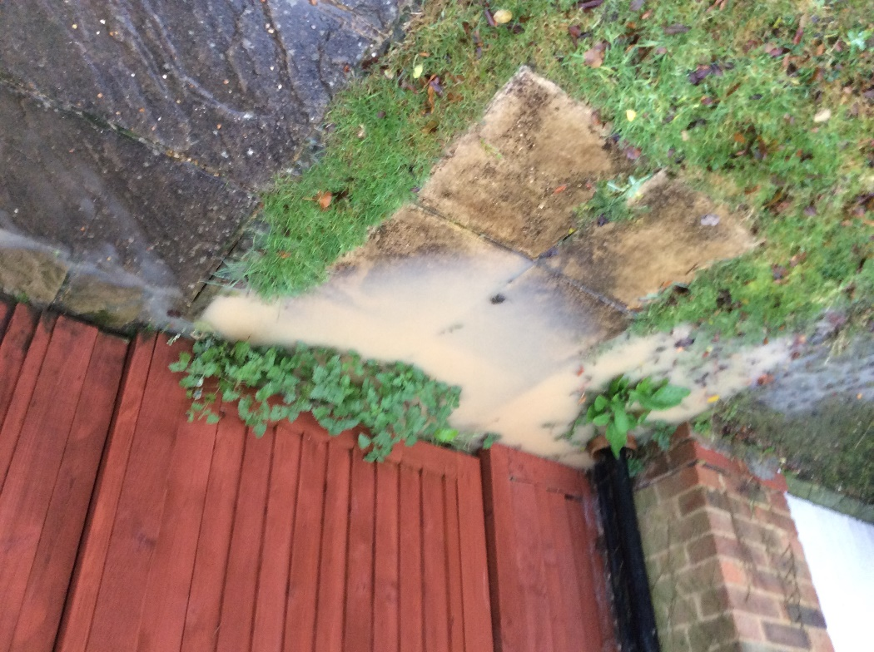

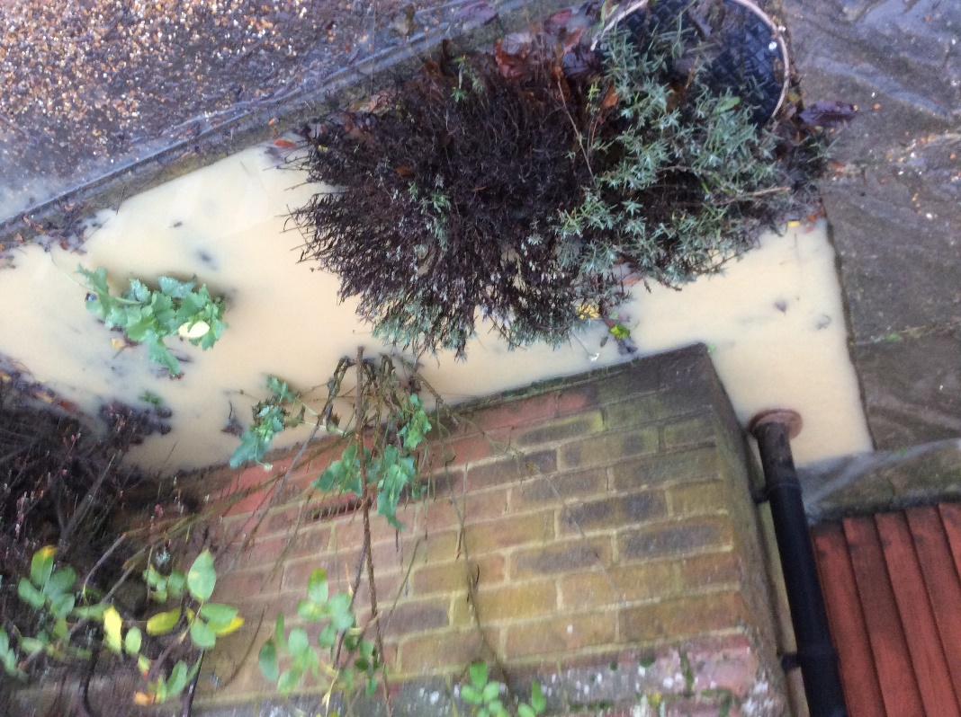

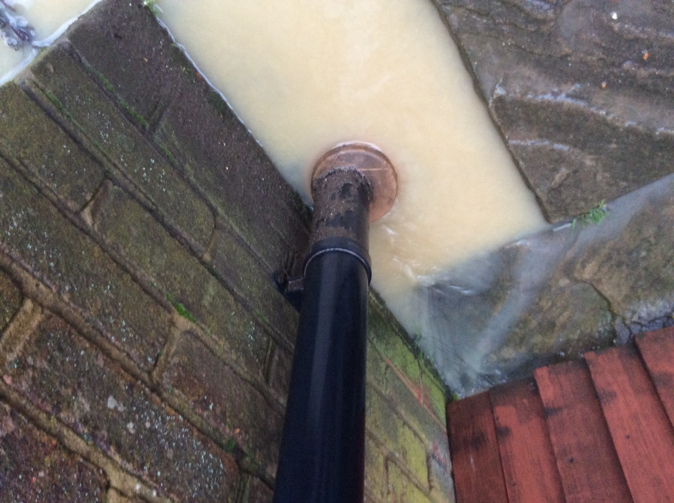

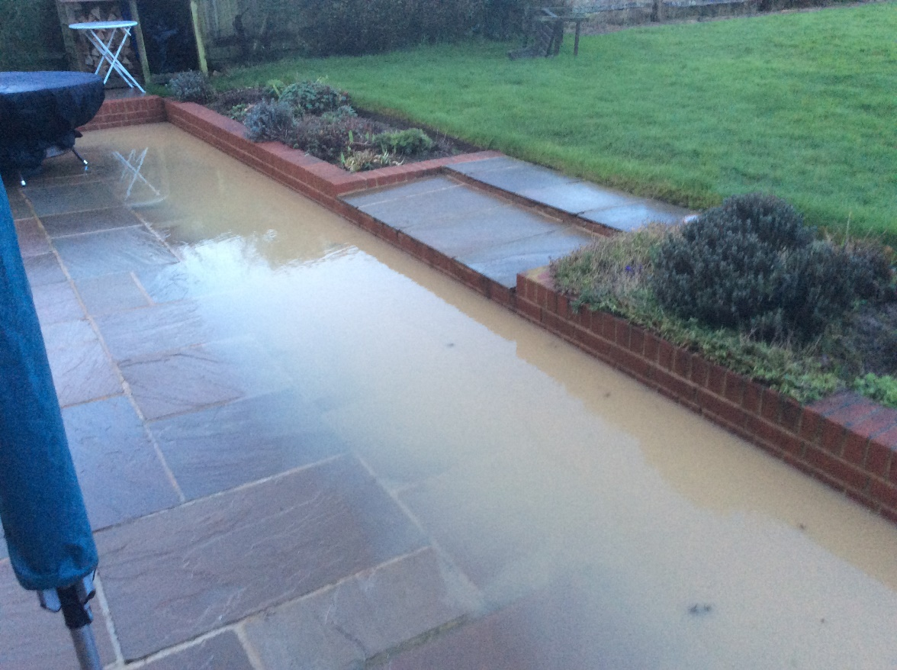

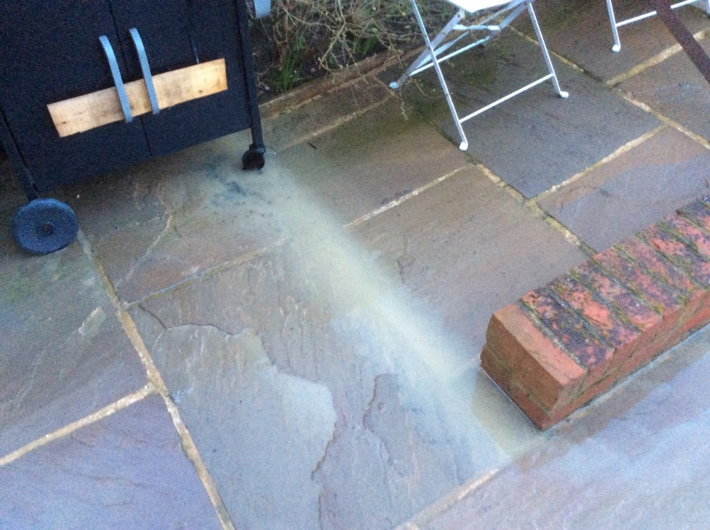

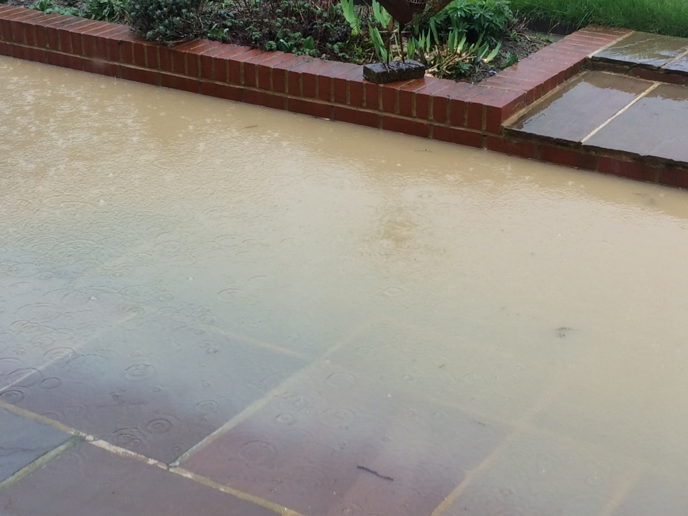

Comment from resident who sent these photos:

We live next door to site 74 and particularly after Storms Ciara and Dennis, water has flooded into our garden from the site. We feel with the proposed development this flooding into our garden will become even worse in wet weather due to the increased roof area and accompanying hard standing which will be inevitable with the planned building construction.

Other Photos

Site 74 – residents driveways (December 2019 and March 2020)

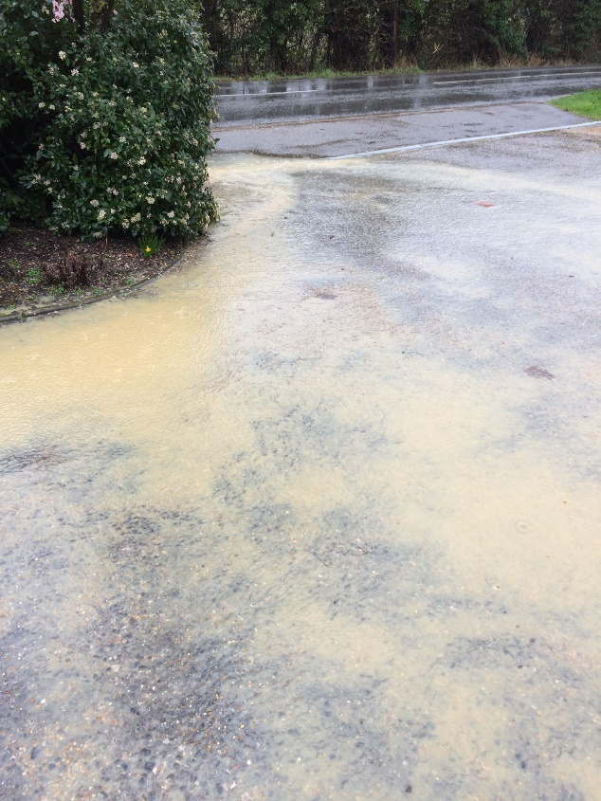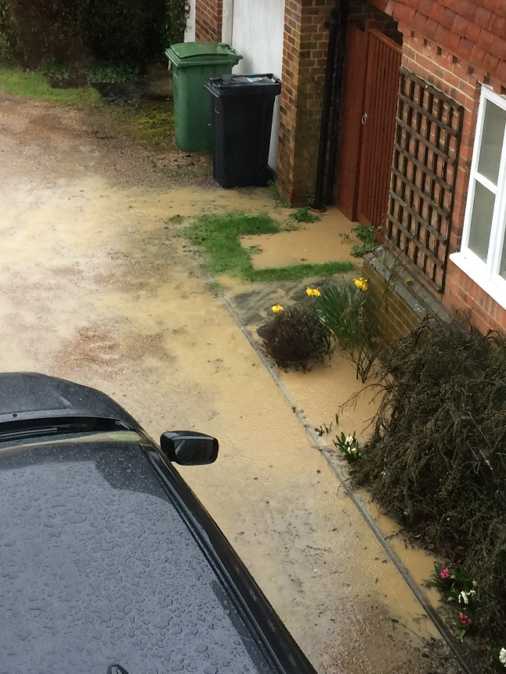

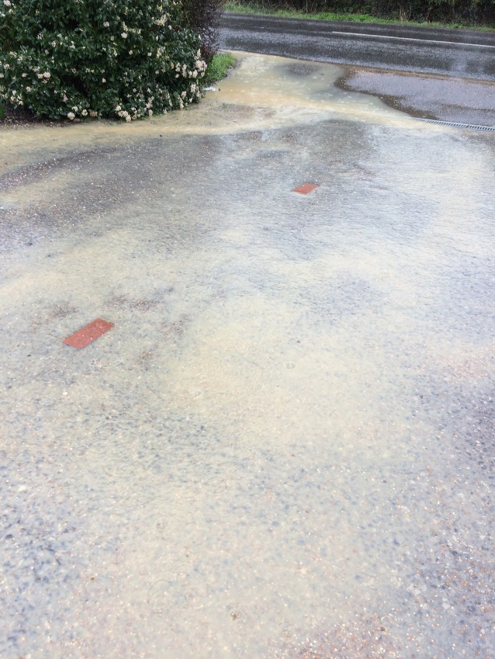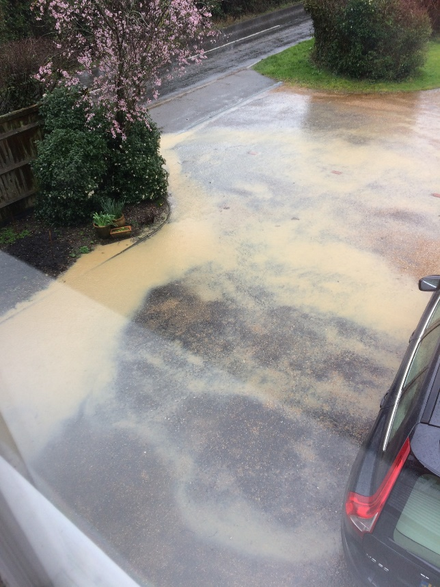

Bunches Lake (site 119) from Park Road towards the railway bridge

